**E Channeling Mobile Application**

**Sketching**

* Channeling Function

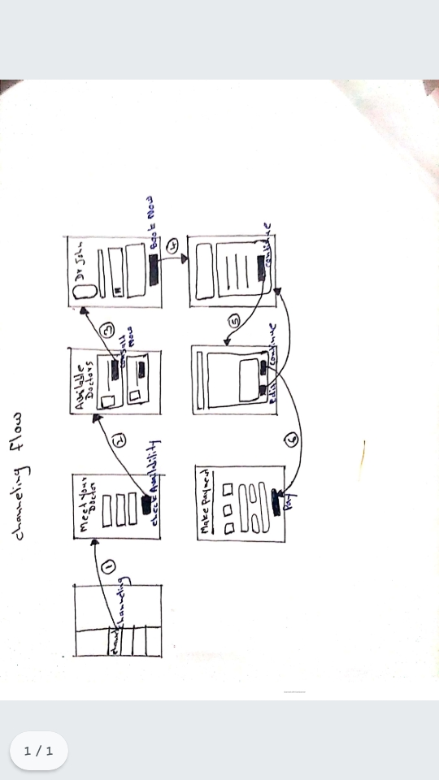

* Pcr Function

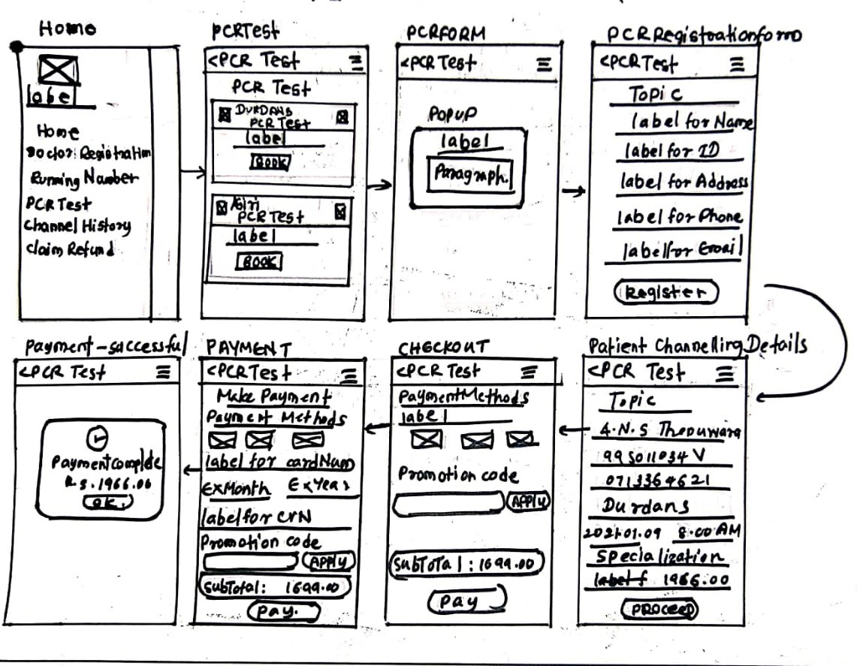

* Driving License medical

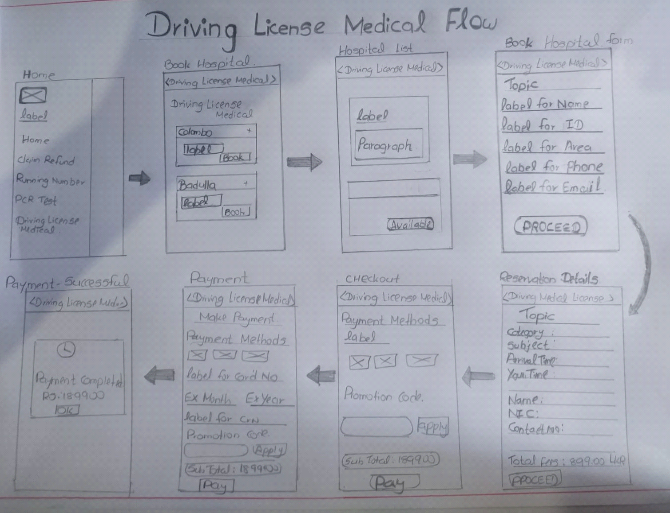

Login, Register, Channeling history, Refund

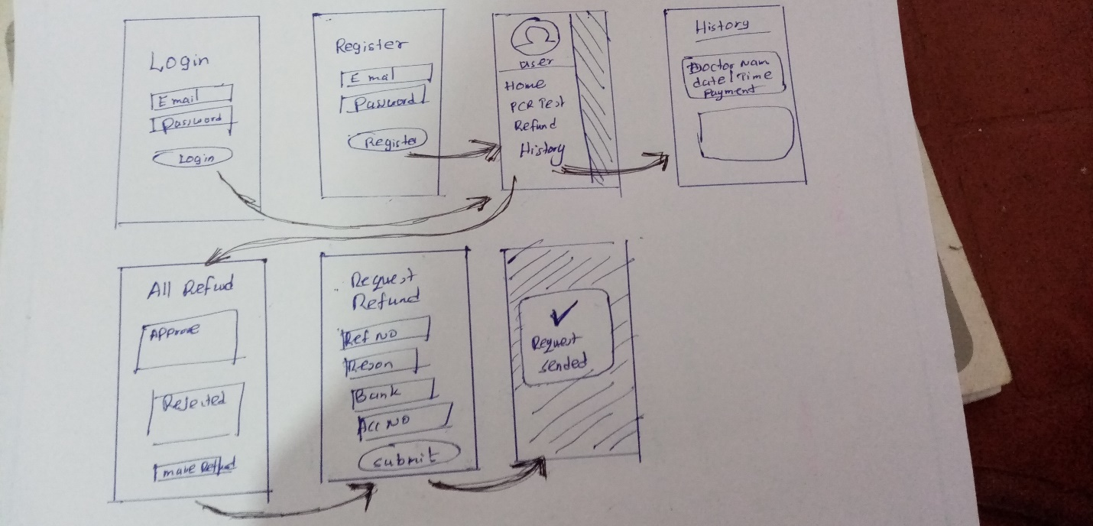

**Wireframes**

Channeling Function

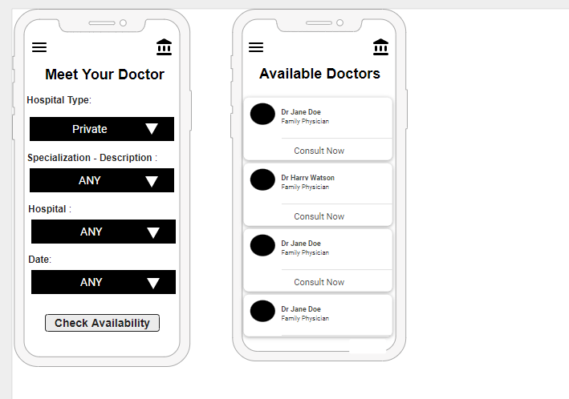

PCR function

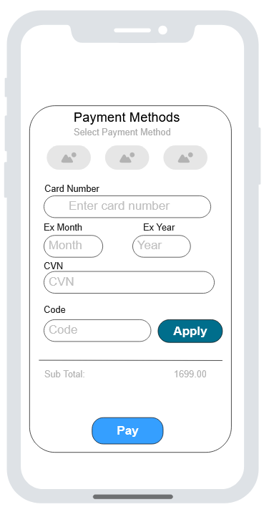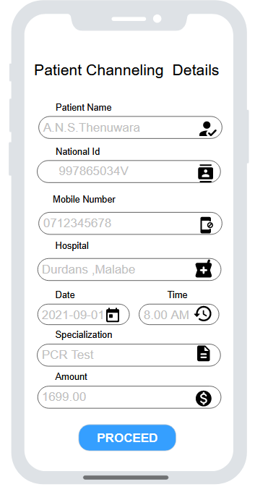

Driving license medical

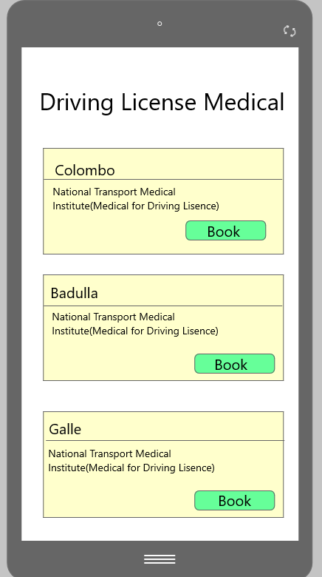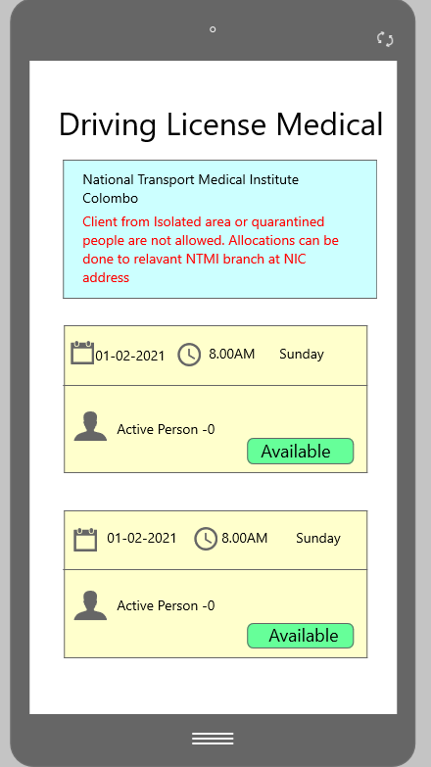

Login, Register, Channeling history, Refund

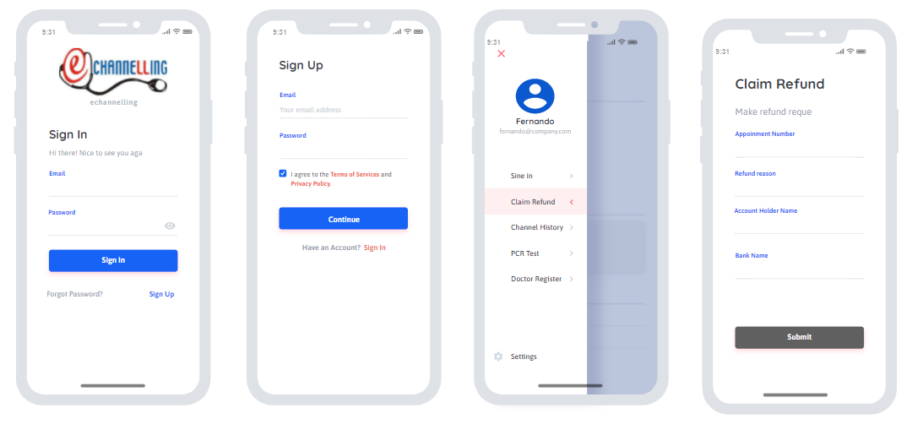

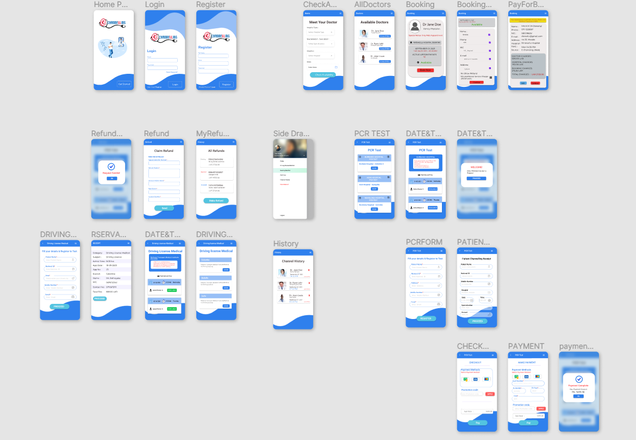**Prototype (High-fidelity)**

**Version 1.0**

**Link :** [**https://www.figma.com/file/MfQkqqj4lUaZziLVsfrdpK/UEE-echannelling-app?node-id=0%3A1**](https://www.figma.com/file/MfQkqqj4lUaZziLVsfrdpK/UEE-echannelling-app?node-id=0%3A1)

**Interview Link (google drive)-** [**https://drive.google.com/drive/folders/1MsviEiqUjE6CMe4JbLTjslu_C4opxGKn?usp=sharing**](https://drive.google.com/drive/folders/1MsviEiqUjE6CMe4JbLTjslu_C4opxGKn?usp=sharing)

Channeling Function

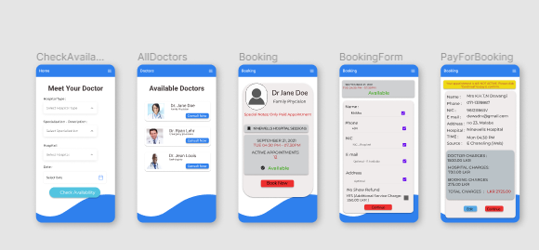 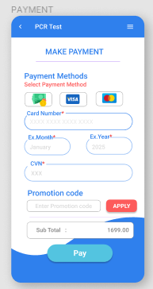

PCR function

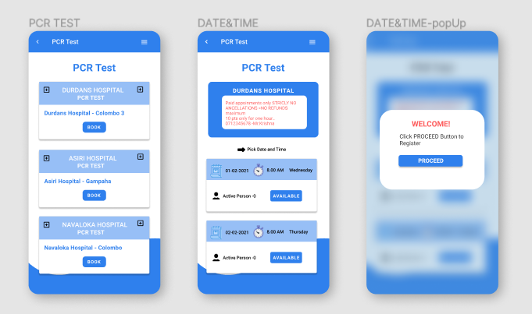

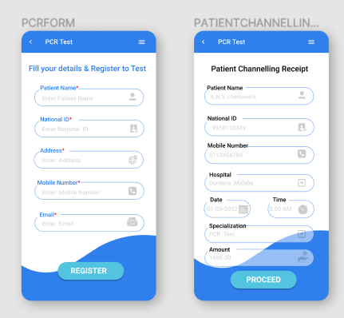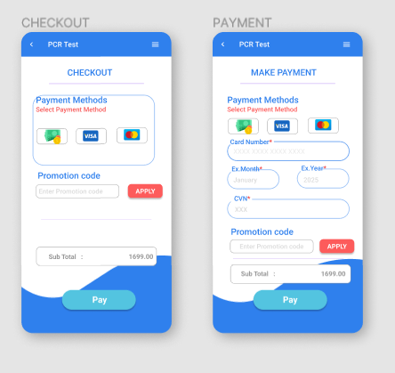

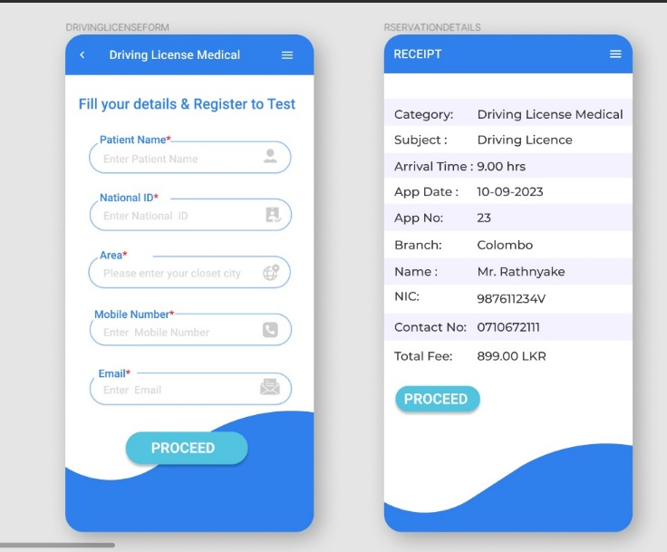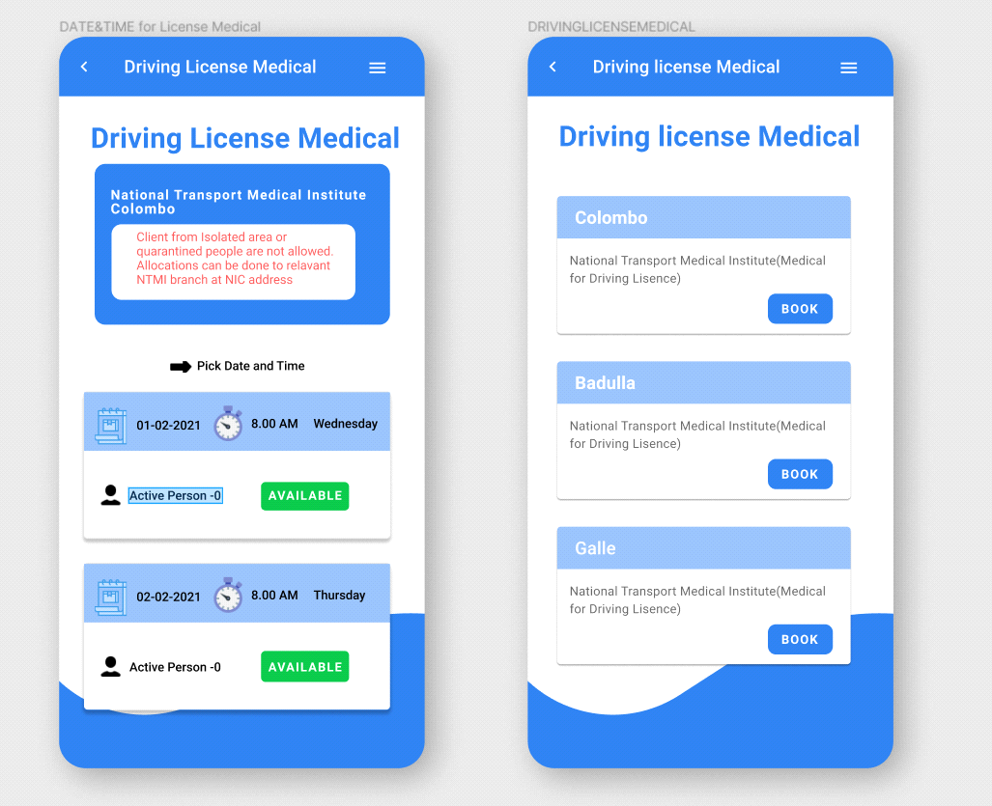Driving license medical

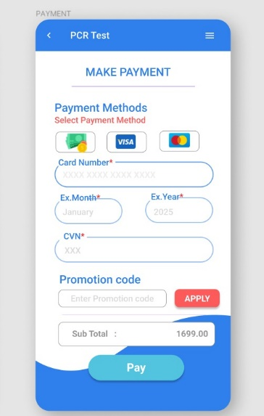

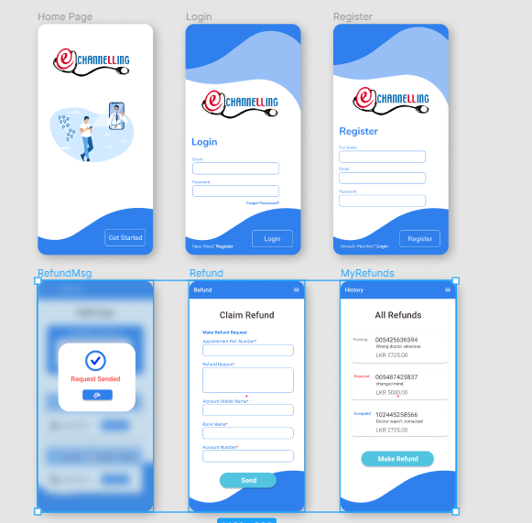Login, Register, Channeling history, Refund

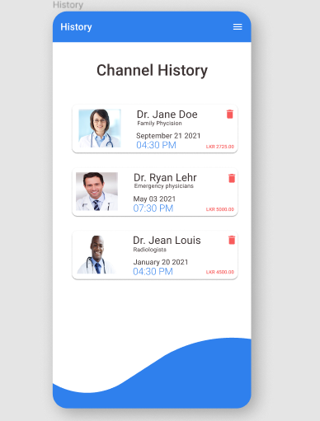

**Version 2**

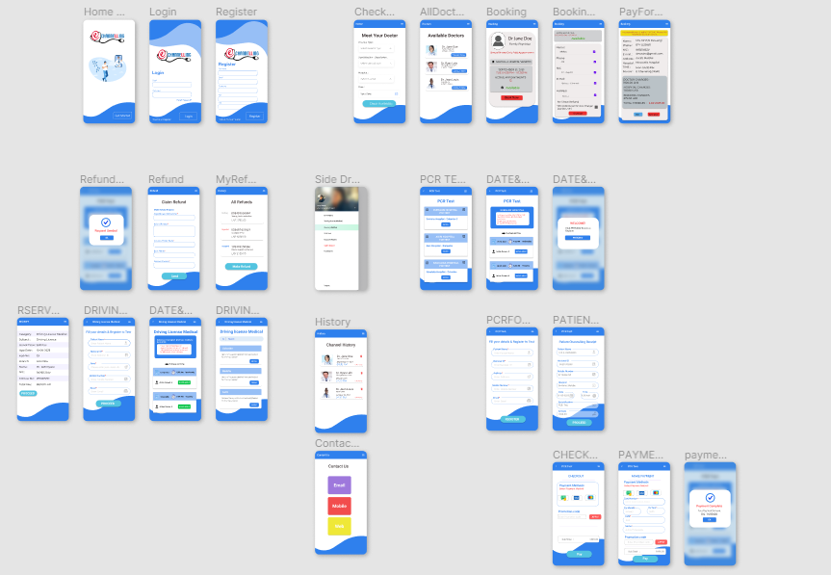

**Link :** [**https://www.figma.com/file/0PABks7V7amDNIbFiKtCp6/UEE---echannelling-app---version-2?node-id=0%3A1**](https://www.figma.com/file/0PABks7V7amDNIbFiKtCp6/UEE---echannelling-app---version-2?node-id=0%3A1)

* Channeling

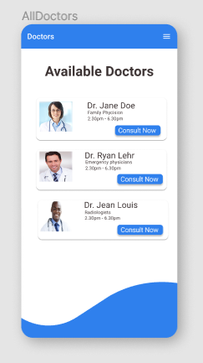

* 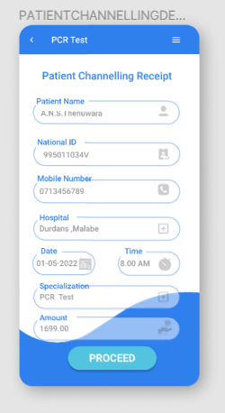PCR Test

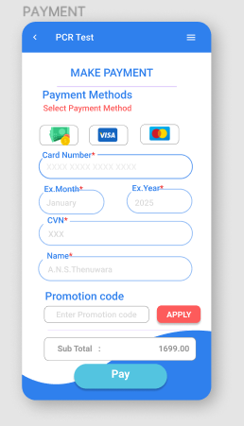

* Driving license medical

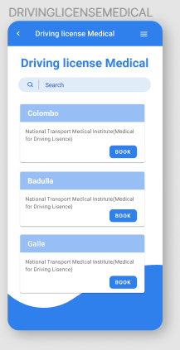

* Login, Register, Channeling history, Refund

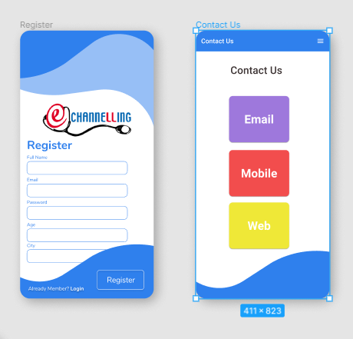

**Contribution**

|  |  |
| --- | --- |
| **IT Number** | **Task** |
| **IT19123196** | **Channeling Function** |
| **IT19159072** | **PCR Test Function** |
| **IT19129518** | **Driving License Medical** |
| **IT19161884** | **Login, Register, Channeling history, Refund** |